|  |  |  |  |
| --- | --- | --- | --- |
| **To be completed by the student** | | **To be completed by the markers** | |
| **Module Name and code** | **2UZF304** | **First Marker’s name**  **(acts as signature)** |  |
| **Tutor Name** | **Aleksey Redninskiy** | **Second Marker’s name**  **(acts as signature)** |  |
| **Student ID (UoW)** |  | **For Registrar’s office use only (hard copy submission)** | |
| **Student ID (WIUT)** | **00003589** |
| **Deadline date** | **16,04,2015** |
| **Individual assignment** | **🗸** |
| **Group assignment** | **🗌** |

**COURSEWORK SUBMISSION COVER PAGE**

**Submission instructions**

**Please note that all work *must* be submitted in *both* Hard Copy to the Registrar’s Office *and* Electronically unless instructed otherwise.**

**For hardcopy submission instructions refer to:** [**http://intranet.wiut.uz/Shared%20Documents/Forms/AllItems.aspx**](http://intranet.wiut.uz/Shared%20Documents/Forms/AllItems.aspx) **- Coursework hard copy submission instructions.doc**

**For online submission instructions refer to:** [**http://intranet.wiut.uz/Shared%20Documents/Forms/AllItems.aspx**](http://intranet.wiut.uz/Shared%20Documents/Forms/AllItems.aspx) **- Coursework online submission instructions.doc**

**Feedback**

**To be completed by markers**

|  |  |
| --- | --- |
| **Assessment criterion and/or learning outcome** | **Marker’s comments and second marker’s comments if appropriate** |
| **1.** |  |
| **2.** |  |
| **3.** |  |

Introduction

Task of the course work 1 was to create the html site, with photos, slides and information. We should use Notepad++, sliders like Nivoslider or CCSSlider, which I used, to create my website. In addition, I wrote report in which I indicated process of my course work.

We were given a list of topics. From what I chose aviation and tried to create my own site. My site will be interesting to all, older 12+ age limit. My web site will include information about aviation itself and about companies which are the giant of air machinery.

Page sketches

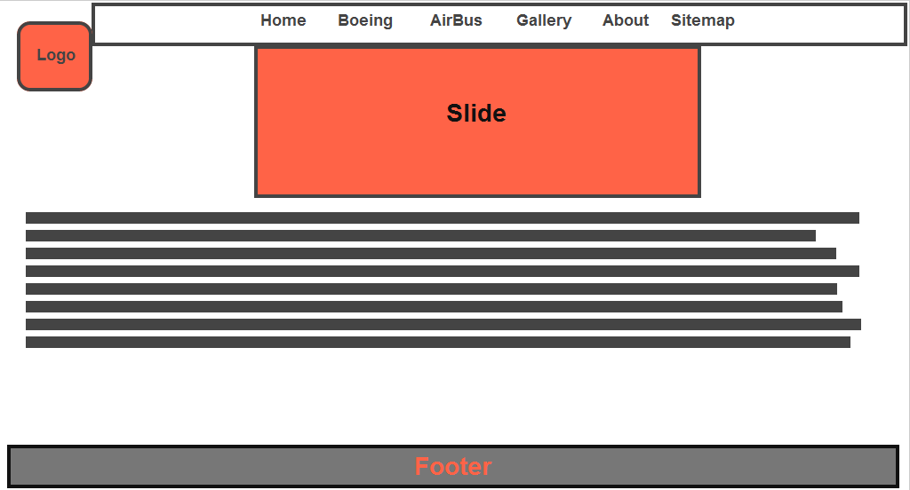

This is the page sketch of my home page. There is logo, slide and menu navigation bar. Then I added a background information about aviation.

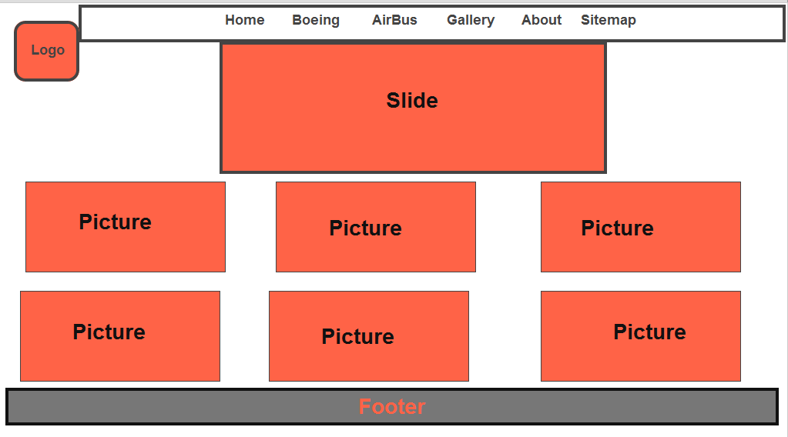

The illustration above shows sketch of gallery page which contains several photos of airplanes.

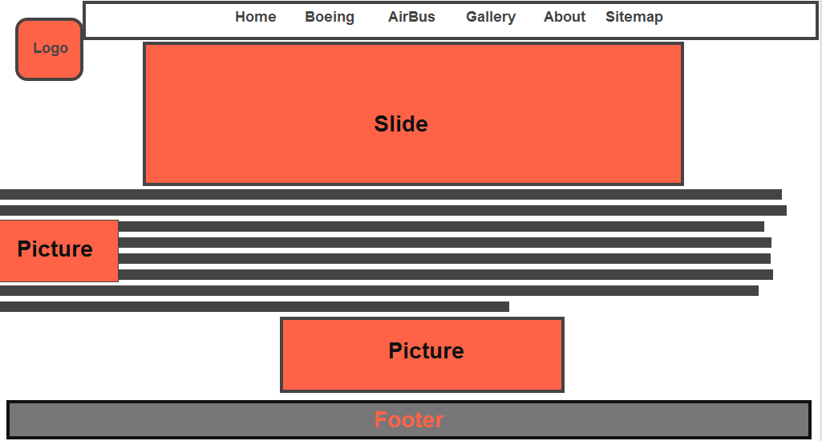

This sketch demonstrates Boeing page, providing information and photos devoted to Boeing. Moreover, slide is also implemented.

My favorite site

My favorite site is [www.boeing.com](http://www.boeing.com) . Boeing is one of the greatest creators of military and commercial air machinery. The reason why it is my favorite site is that the design of this site is great. Moreover, it is connected to my childhood memories and dreams. As I wanted to become pilot and I don’t forget about it. So I still have an interest on aviation.

Code clarification

Navigation

href="css/style.css”> with the help of this link I connected my html to dropdown-menu’s css file. Then I put next code to add menu navigation.

<html>

<head>

<link rel="shortcut icon" href="logo1.jpg" type="image/x-icon" />

<meta http-equiv="Content-Type" content="text/html; charset=utf-8" />

<title>Aviation</title>

<link href="css/style.css" rel="stylesheet" type="text/css" />

</head>

<body id="romp">

<div class="container">

<!-- Header -->

<div class="container" id="Header">

<div class="menu bubble">

<table width="566" class="text" id="table">

<tr>

<td><a href="Home.html" style="color:#99FF33">Home</a></td>

<td><a href="Boeing.html" style="color:#99FF33" class="active">Boeing</a></td>

<td><a href="AirBus.html" style="color:#99FF33">AirBus</a></td>

<td><a href="Gallery.html" style="color:#99FF33">Gallery</a></td>

<td><a href="About.html" style="color:#99FF33">About</a></td>

<td><a href="Site map.html" style="color:#99FF33">Site map</a></td>

</tr>

</table>

</div><a href="Home.html"><img src="logo1.jpg" width="180" height="160" class="logo" /></a>

<p><a href="http://wiut.uz"><img src="logo.png" alt="Go to WIUT Home Page" width="200" height="52" class="logo2" longdesc="http://wiut.uz" /></a>

</p> After adding this code I changed it as I want in order to fit my website.

CSS

@charset "utf-8";

/* CSS Document */

* {margin:0; padding:0;}

body {background:url(../background2.jpg) fixed center;}

#romp {height:100%; position:relative;}

.container {width:1000px; margin-left:auto; margin-right:auto;background:hidden;}

#Header {}

.menu {

-webkit-border-bottom-left-radius: 30px;

border: 1px #FFFFFF groove;

-webkit-border-bottom-right-radius: 30px;

position:fixed;

margin-left: auto;

margin-right: auto;

top: 0;

alignment-baseline: central;

width: 1000px;

height: 34px;

color: #FF0000 "red";

z-index:100;

}

.bubble {

background: #95c2fd;

background-image: -webkit-gradient(linear, left bottom, left top, color-stop(0.15, #000000), color-stop(1, #030555));

background-image: -webkit-linear-gradient(bottom, #000000 15%, #2096e8 100%);

background-image: -moz-linear-gradient(bottom, #000000 15%, #2096e8 100%);

background-image: -ms-linear-gradient(bottom, #000000 15%, #2096e8 100%);

background-image: -o-linear-gradient(bottom, #000000 15%, #2096e8 100%);

background-image: linear-gradient(bottom, #000000 15%, #2096e8 100%);

filter: progid:DXImageTransform.Microsoft.gradient(GradientType=0,startColorstr='#030555', endColorstr='#000000');

-webkit-box-shadow: inset 0 8px 5px rgba(255,255,255,0.65), 0 1px 2px rgba(0,0,0,0.2);

-moz-box-shadow: inset 0 8px 5px rgba(255,255,255,0.65), 0 1px 2px rgba(0,0,0,0.2);

box-shadow: inset 0 8px 5px rgba(255,255,255,0.65), 0 1px 2px rgba(0,0,0,0.2);

}

#table { margin-right:auto; margin-left:auto;}

.text {font-family:"Times new roman", Times, serif; margin:0 30px 0 30px; color:#FF0033; font-size:24px; text-align:center; font-weight:800; font-variant:small-caps; alignment-adjust:before-edge;}

.logo {margin:25px 0 0 0; position:absolute; left:10px; list-style-type:upper-roman; z-index:90;}

.logo2 {margin:25px 0 0 0; position:absolute; right:10px; list-style-type:upper-roman; z-index:90;}

a:hover,

a.active {text-shadow:#FFF 0px 0px 15px;}

.slide {margin-top:10px; margin-left:auto; margin-right:auto; height:350px; width:900px; border-radius:5px; overflow:hidden;}

#content {border-top:#FFF 2px groove; border-bottom:#FFF 2px groove;height:800px; min-height:650px; margin-top:10px;}

#left {float:left; width:950px; height:100%;}

#left2 {float:left; width:650px; height:46%;}

#left3 {float:left; width:650px; height:46%;}

.Big {font-size:28px; color:#0FF; font-weight:bold; font-variant:small-caps;}

.Big2 {font-size:28px; color:red; font-weight:bold; font-variant:small-caps;}

.Small {font-size:16px; font-family:Arial, Helvetica, sans-serif; color:#FFF; text-shadow:#0CF 0px 0px 5px;}

.margin {margin:10px;}

#right {float:right; width:350px; height:100%; }

.Big2 {font-size:22px; color:#0FF; font-weight:bold; font-variant:small-caps;}

.Small2 {font-size:12px; font-family:Arial, Helvetica, sans-serif; color:#FFF; text-shadow:#0CF 0px 0px 5px; word-spacing:10px;}

.inim {border:3px #CCCCCC solid; margin:4px;}

.gallery {border:6px #00FFFF groove; margin:14px;}

#footer {border-top:#FFF 2px groove; margin-top:3px; margin-bottom:10px; border-bottom:#CCC 3px groove; min-height:150px;}

.wiut { margin-left:440px; margin-top:40px;}

.wiut2 { margin-left:440px; margin-top:0px;}

Java script

CSSSlider

/* ------------- General ------------- */

@font-face {

font-family: "cs-ctrl-basic";

src: url("cs-ctrl-basic.eot");

src: url("cs-ctrl-basic.eot#iefix") format("embedded-opentype"),

url("cs-ctrl-basic.woff") format("woff"),

url("cs-ctrl-basic.ttf") format("truetype"),

url("cs-ctrl-basic.svg#basic") format("svg");

font-weight: normal;

font-style: normal;

}

.csslider1 {

display: inline-block;

position: relative;

max-width: 1000px;

width: 100%;

}

.csslider1,

.csslider1 *,

.csslider1 *:after,

.csslider1 *:before {

-webkit-box-sizing: content-box;

-moz-box-sizing: content-box;

box-sizing: content-box;

}

.csslider1 > .cs_anchor {

display: none;

}

.csslider1 > ul {

position: relative;

z-index: 1;

font-size: 0;

line-height: 0;

margin: 0 auto;

padding: 0;

overflow: hidden;

white-space: nowrap;

}

.csslider1 > ul > .cs_skeleton {

width: 100%;

visibility: hidden;

font-size: 0px;

line-height: 0;

}

.csslider1 > ul > .slide.img img {

width: 100%;

}

.csslider1 > ul > .slide.img a {

font-size: 0pt;

color: transparent;

}

.csslider1 > ul > .slide {

position: relative;

display: inline-block;

width: 100%;

height: 100%;

overflow: hidden;

font-size: 15px;

font-size: initial;

line-height: normal;

white-space: normal;

vertical-align: top;

-webkit-box-sizing: border-box;

-moz-box-sizing: border-box;

box-sizing: border-box;

-webkit-transform: translate3d(0,0,0);

transform: translate3d(0,0,0);

}

.csslider1 .cs_engine{

position: absolute;

top: -9999px;

left: -9999px;

font-size: 0pt;

opacity: 0;

filter: alpha(opacity=0);

}

.csslider1 > ul > li.img,

.csslider1 > .cs_arrowprev,

.csslider1 > .cs_arrownext,

.csslider1 > .cs_bullets,

.csslider1 > .cs_play_pause {

-webkit-touch-callout: none;

-webkit-user-select: none;

-moz-user-select: none;

-ms-user-select: none;

user-select: none;

}

With the help of cssslider I added slide show to my home page.

Conclusion

To conclude, during the Coursework1 I have learnt how to create new websites, how to use different programs and how to write report. Although I have encountered several difficulties, in fact they helped me to improve my skills.